1. **Write a C program to find Factorial of a given number using Recursion.**

**PROGRAM:**

#include <stdio.h>

unsigned long long factorial(int n);

int main() {

int number;

printf("Enter a non-negative integer: ");

scanf("%d", &number);

if (number < 0)

printf("Error! Factorial of a negative number doesn't exist.");

else

printf("Factorial of %d = %llu", number, factorial(number));

return 0;

}

unsigned long long factorial(int n) {

if (n == 0)

return 1;

else

return n * factorial(n - 1);

}

**INPUT:**

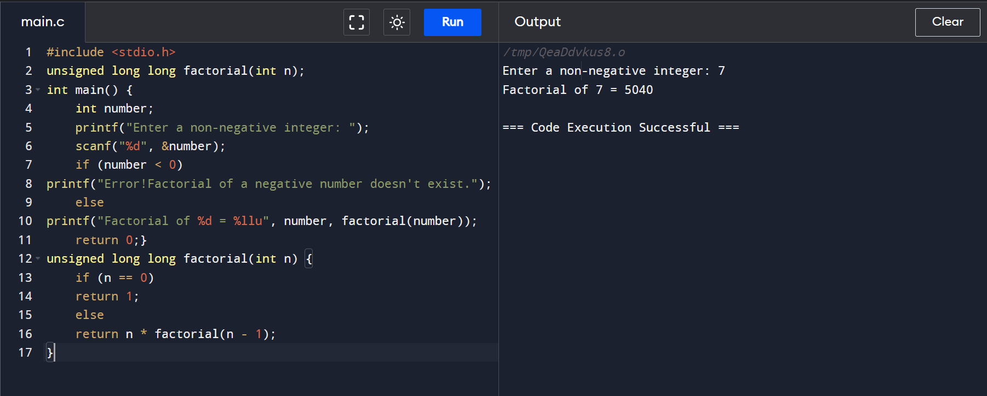

**OUTPUT:**

